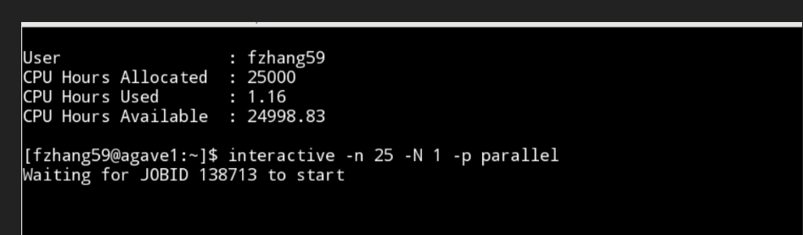

Netlogo and Rstudio on Agave

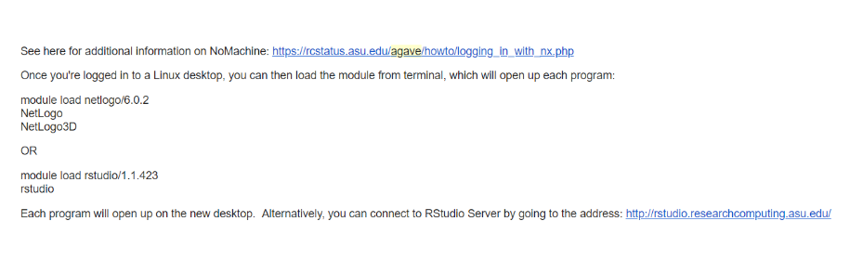

Start an interactive node, can just simply use “interactive”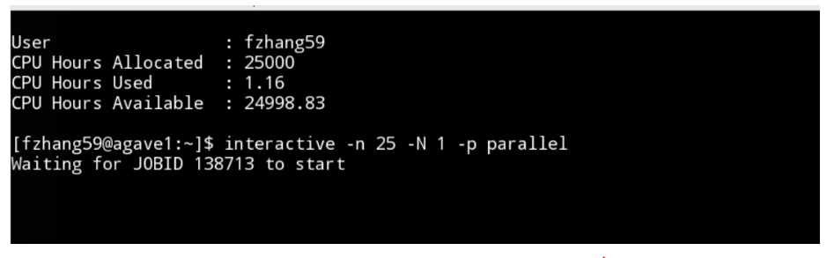

Pull git, and set directory

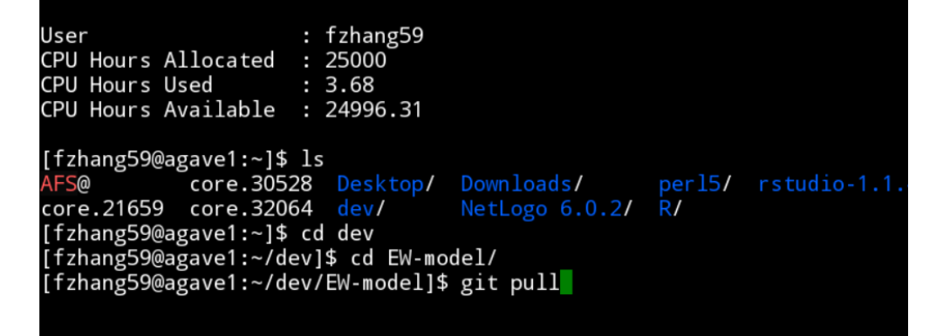

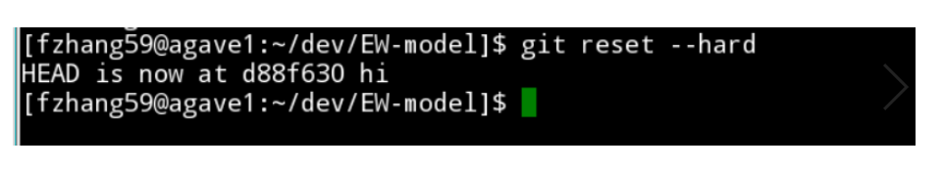

Set Directory when there is space in the name:

git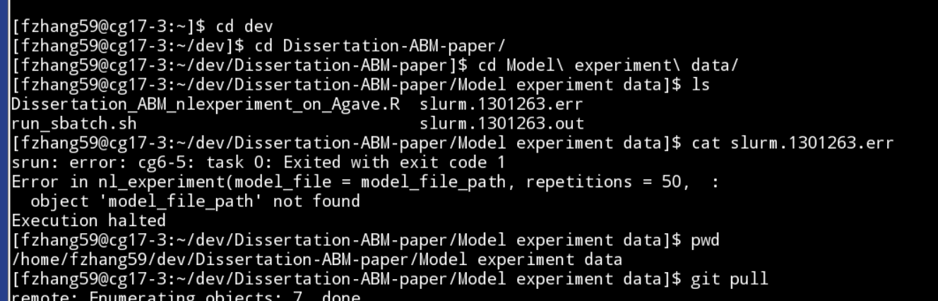

Commit changes on Agave:

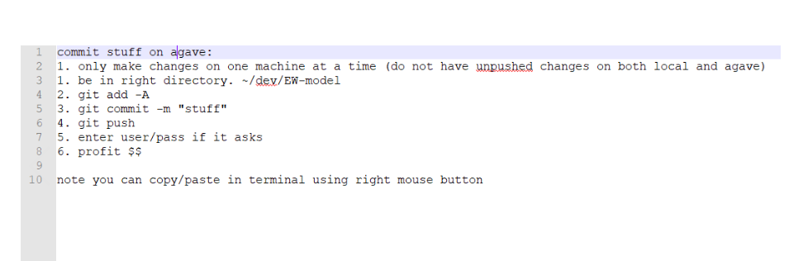

Git overwrite on agave

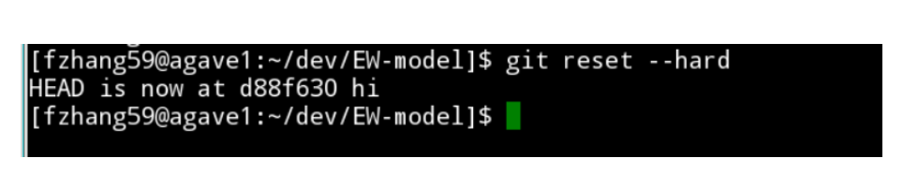

On agave

How to find directory:

1. type “interactive”
2. download your data from git
3. type “sbatch run {your script name}”
4. to see your jobs type “sbatch -u fzhang59”
   1. this may only show your interactive session
5. to see your job type “scontrol show job {job id}”
6. check error files “ls”
7. to see file use “cat filename”, such as “cat Dissertation_ABM_nlexperiment_on_Agave.R”